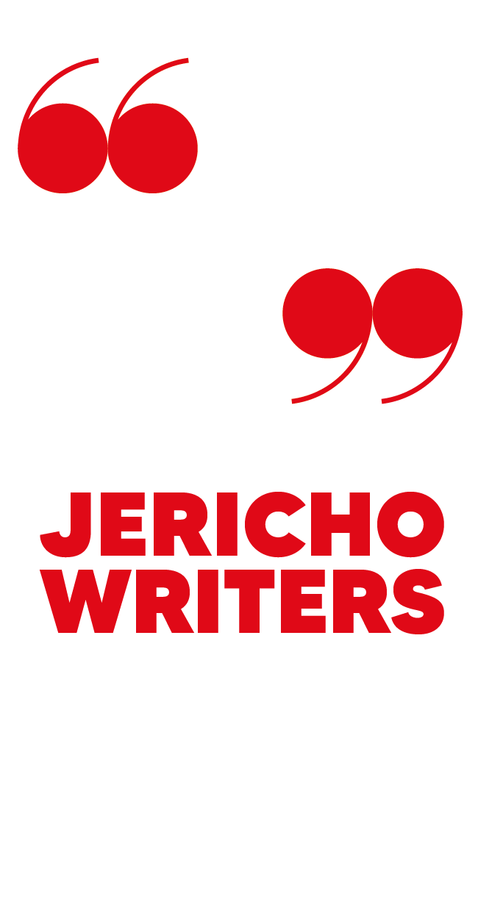

1 HOUR QUERY LETTER AND SYNOPSIS BUILDER

FIND OUT MORE ABOUT BECOMING A MEMBER

WHAT THIS TOOL DOES:

- Gives you a draft query letter and synopsis in an hour.

- Clearly defines your pitch, novel structure, and the emotional architecture of your story.

- Will present you as a knowledgeable, professional author.
Literary agents require information in a specific structure.
In your Synopsis Builder, you’ll work from structure up, instead of trying to condense your finished book into 500 words. It’ll help you understand and revisit the heart of your story.
USING YOUR QUERY LETTER BUILDER
Simply fill in the template.
You’ll have your first drafts in under an hour, so use the time remaining to edit your letter into shape until it’s perfect.
PRO TIPS:
- Check what your literary agent wants. You’ll need to adapt this letter for different agents. Don’t forget to change agents’ names!
- Adopt the tone of a capable, professional author. Keep it succinct, because agents’ time is limited, so don’t ramble. Don’t sound apologetic, and don’t sound arrogant. Keep focus on your story, not yourself.
- Take care with language. Proofread carefully. Avoid awkward sentencing, poor punctuation, and subtle typos. You are seeking to market yourself as a writer, so don’t let yourself down with obvious mistakes.
BUT FIRST: Are you serious about getting an agent? Our essential 'How To Get A Literary Agent’ course offers a complete guide to not only writing your query letter, but perfecting your entire submission package.

1 HOUR QUERY LETTER – WORKSHEET
INTRO
The normal practice is to write “Dear Firstname Lastname”, no matter whether you’re submitting work by email, web-form, or post.
If you don’t have an agent’s name (or if they specifically ask you to send it to their general submissions department), then write “Dear Submissions”, or “To whom it may concern.” It’s not as ideal as writing their name, but it is at least professional.
Be careful with names. Is it Tania or Tanya? Jon or John? Double-check your spelling.
Intro  Example: Dear Emily Glenister, | Replace text with your own…
OPENING PARAGRAPH: Sentence 1
This is where you explain why you’re writing, the title of your manuscript, genre and word count, rounded to the nearest 5,000 words.
Reason to write | Say outright that you are writing to seek their representation.
On title | Titles are best set in italics. All titles are provisional until a publisher agrees. Don’t say “working title”, or anything like that.
On genre | If your novel has an obvious genre, e.g. fantasy, then reference this. If it doesn’t, explain (e.g.: “a literary fiction romance set in 1960s Berlin”). There may be genre-crossover, but agents need to sell your book to publishers. It’s in your interest to choose a genre.
SENTENCE 1
Sentence 1  Example: I’d like you to consider representing my psychological suspense novel THE GIRL BEYOND THE GATE, complete at 81k words. I would position THE GIRL BEYOND THE GATE beside novels such as THE BABYSITTER by Phoebe Morgan, STRANGERS by C.L Taylor and THE PUSH by Ashley Audrain. | Replace text with your own…
OPENING PARAGRAPH: SENTENCE 2A (OPTIONAL)
If you need to say more about genre, do so here. This is only necessary if you’re writing fiction doesn’t have a clear genre. Just offer a sentence giving a swift idea of the book they’re dealing with.
Sentence 2a  Example: My novel deals with the struggles of Ernst, an East German border guard, to find love with Magda, an expressionist artist trying to make ends meet in West Berlin. | Replace text with your own…
OPENING PARAGRAPH: SENTENCE 2B (OPTIONAL)
If you have a strong reason to write to a certain agent, say it here (but don’t make things up.) If you’ve already chosen to expand upon your manuscript (e.g. Sentence 2A), wait until the end to tell the agent why he or she is special to you.
Sentence 2b  Example: I’m submitting to you not only because I think you’ll enjoy my novel and have represented similar authors such as S.V. Leonard, but because I think our personalities will mesh well (I also went to drama school, swear a lot and think I’m funnier than I am!) | Replace text with your own…

MAIN PARAGRAPH: EXPLAINING THE WHY (20 – 50 WORDS)
Having explained what the book is, explain why your book is exciting and necessary. This is your elevator pitch: short, vivid, compelling. It may be as little as a dozen words. Don’t worry about giving away your big surprise. Just tell us your hook and what’s different about your book.
Explaining the why  Example: When two women begin fighting to save the same child, the results are deadly. | Replace text with your own…

MAIN PARAGRAPH: EXPLAINING THE WHAT
(70 - 100 WORDS)
This is where you explain in detail what the book is about. You’re not writing a blurb, just explaining what kind of book this is to someone who only has time to read 70-100 words.
Explaining the what  Example: Arriving at her new home in the exclusive gated community of Kensington Grove, journalist Jodie Evelyn instantly feels on edge - and not just because this is her final desperate attempt to start afresh after her daughter’s tragic death. Though it’s beautiful, something about the community, built around a converted psychiatric hospital, unnerves her - as does her new neighbour Norah Williams and her terminally ill teenage daughter Lacey. When a death rocks the community, she suspects Norah may have been involved and sets out to save Lacey from her mother. But as Jodie dives deeper into Norah’s shadowy past, she’s forced to come face to face with her own, with devastating consequences. | Replace text with your own…
AUTHOR PARAGRAPH: MOST FICTION WRITERS (1 SHORT PARAGRAPH)
Most fiction writers can get away with very little here. Agents are interested in your manuscript. Keeping this short will work well for most authors, but do include any writing credits (including being a member of Jericho Writers!) before any personal details. If there is a genuinely interesting link between your background and the substance of the novel, you’ll probably want to say so here.
Most fiction writers  Example: I work full-time as a writer and editor for a parenting website, and I co-run Reading Parties with William Shaw. It’s an online book reading business where I’ve had the pleasure of working with authors such as C.L Taylor, Will Dean, David Fennell, Sarah Pearse, Phoebe Morgan and a variety of publishing industry professionals. I was also runner up in Outlet Publishing's Short Story Competition, and I am being mentored by the wonderful Lauren North. I live in Surrey, where I am raising a little reader of my own. | Replace text with your own…

AUTHOR PARAGRAPH: LITERARY FICTION WRITERS (1 SENTENCE)
If you’re writing literary fiction (e.g. Annie Proulx, Ian McEwan, etc.), you probably want a paragraph that links themes of the novel to your own experience. It’s fine for literary authors to write a letter running to a second sheet.
Literary fiction writers  Example: The novel explores themes of silence and remembrance – symbolised in the novel by the ruined monastery. The ideas came to me during a lengthy silent retreat on the island of Iona and were finalised during my experience of caring for my dying mother. | Replace text with your own…
AUTHOR PARAGRAPH: NON-FICTION WRITERS (1 – 3 SENTENCES)
Non-fiction authors may need to use several paragraphs to explain:
THEIR AUTHORITY:
- You show you know what you’re talking about, e.g.: “I’m a Professor of Particle Physics, and have won numerous awards for my research.”
THEIR PLATFORM:
- You can show you have an audience, e.g.: “My YouTube videos receive 11 million monthly views. I have more than 400,000 followers on Instagram.”
Some writers will have significant authority, but no great platform, and others will have a powerful platform, but no great authority. Either can work for agents. If your professional biography is relevant, you may wish to create a separate document. Non-fiction writers, like literary ones, may have a query letter of two pages.
Non-fiction writers  Example: See examples above. | Replace text with your own…
CLOSING REMARKS (2 – 3 SENTENCES)
Your closing remarks should, firstly, signpost what you’ve attached – this makes it easy for the agent to see that you’ve followed their submission guidelines, and for them to know what you’ve sent. You should also thank the agent. Any declaration re. hearing from them needs to be confident – not ‘I hope you like this’, but that you look forward to speaking soon. You’ve written a whole book, that’s something to be confident about!

Closing remarks  Example: I enclose my opening three chapters and a synopsis. I hope you enjoy the extract and look forward to hearing from you at your earliest convenience. | Replace text with your own…

1 HOUR QUERY LETTER – CHECKLIST
I’ve checked the spelling of an agent’s name and agency.
I’ve checked the agent’s submission requirements.
I’ve checked for typos, poor sentence construction, etc.
My page fits onto one side of paper. (Literary authors and non-fiction authors can use
two pages if they need to.)
My opening paragraph conveys basic details quickly.
My main paragraph clearly states what kind of book I’ve written.
My elevator pitch is strong and appealing.
I come across as a confident, professional author.
My closing section is short and sweet.
If you have a string of yeses, then lay your letter to one side, review it again tomorrow, and you’re good to go.

USING YOUR SYNOPSIS BUILDER
TASK 1: PLOT STRUCTURE
Write the plot structure of your novel in sections: Status Quo, Initiating Incident, Developments, Crisis, Resolution. Your structure summary will be about 250 words. The worksheet includes sample text (in dark grey) to get you started. Delete and replace it with your own.
Time allowance: 30 minutes
TASK 2: EMOTIONAL ARCHITECTURE
Now layer in the emotional architecture of your novel. This addition will add about 150 words.
Make sure there is some emotional language in each of the sections. It’s fine just to say what that emotion is, rather than evoke it.
For example, this is fine in a synopsis to agents:
‘Oscar announces his decision and Jane feels bereft.’

This is not fine:

‘Oscar announces his decision and Jane feels as though her heart has been plucked from her chest.’

Remember that agents receive thousands of submissions, so you’ll only have so many words to engage and hold attention. Too much emotional language takes up room in your synopsis.
Just give as much detail as is needed.
Time allowance: 20 minutes
TASK 3: REVIEW AND EDIT
Read through your synopsis. Check the character introductions you need are present. Add anything that strikes you as essential. Give yourself an extra 100 words or so as you complete this.
Time allowance: 10 minutes
PRO TIPS
- Work on plot structure first, then on emotional architecture.
- Use short introductions when first introducing a character.
- Use bold or CAPITALS to highlight the first use of character names.
- Don’t worry about sentence structure or writing beautiful English. For now, just produce a decent first draft.
1 HOUR SYNOPSIS BUILDER – WORKSHEET
STATUS QUO. TARGET WORD COUNT: 30-40
Describe your character’s situation at the start of the novel.
Plot Summary  Example: ALY (32) is an unmarried fashion designer working in New York. She has her own studio and is on the brink of real success. | Replace text with your own…

Describe your character’s emotional situation
Emotional Architecture  Example: Despite her career hopes, Aly is unfulfilled and unhappy with the shallowness of the fashion world. | Replace text with your own…
INITIATING INCIDENT. TARGET WORD COUNT: 50-60
Describe what happens to break the initial status quo.
Plot Summary  Example: Working late on her own designs, Aly studies some Belle Époque fashion plates and finds herself inadvertently time-slipping to late 1890s Paris. There she meets JEAN-PAUL (37), an artist and a self-professed dilettante. | Replace text with your own…
Describe your character’s emotional situation.
Emotional architecture  Example: Waking up again in contemporary New York, Aly becomes sharply aware of the love lacking in her own life. | Replace text with your own…
DEVELOPMENTS. TARGET WORD COUNT: 150-200
Describe how things develop from Initiating Incident to Final Crisis.
Plot Summary | Replace text with your own…
Example: Along with her sister, CARA, Aly tries to expand her horizons by trying new things, such as salsa dancing, life drawing and Parisian cookery, but no one she meets makes her feel the way Jean-Paul did.

Working together, Aly and Cara discover that the Belle Époque fashion plates have caused numerous mysterious disappearances in the past. Aly tries to re-create the conditions she faced before and finds herself once again in the company of Jean-Paul.

As they fall in love, Aly finds more and more excuses to stay with him, and her business, as well as her relationship with Cara, starts to suffer. Cara demands Aly destroy the plates, but Aly is too blinded by love to see the damage they are doing. Instead, she casts Cara off and announces that she is disappearing into the past forever.
Describe the key emotional turning points in this section. You will probably want to filter them into the paragraphs above rather than including a separate section here.
Emotional architecture | Replace text with your own…
CRISIS. TARGET WORD COUNT: 50-75
Describe the crisis that triggers the final showdown and resolution.
Plot Summary  Example: Although Aly is happy with Jean-Paul for a while, she realises she isn’t complete in this strange world without her sister. | Replace text with your own…

Describe the key emotional transition(s) for your character(s).
Emotional Architecture  Example: She is devastated to have to choose between a life with Jean-Paul and happiness with her business and sister, but finally realises that she was foolish to give up everything she has ever held dear to be with a man. | Replace text with your own…
RESOLUTION. TARGET WORD COUNT: 50-75
Describe the final resolution of the crisis, and the book.
Plot Summary  Example: She returns to present day and discovers Cara has been desperately researching into the plates, trying to find her. They make up and Aly tells her she is ready to come home. Cara however, has another idea. She finds a way to bring Jean-Paul into their world instead. | Replace text with your own…

Describe how your characters are left at the end of the novel. In most cases, we would expect to see a reversal or change when compared with the ‘Status Quo’ section.
Emotional Architecture  Example: Jean-Paul settles into modern-day life like he was supposed to be there all along. Aly picks up again on her career, this time with the love and support of both her sister and Jean-Paul. | Replace text with your own…

1 HOUR SYNOPSIS BUILDER – CHECKLIST
Word count | I have approximately 450-550 words.
Character names | I give brief character portraits on first introduction. Character names are in bold or capitals on first introduction. I have restricted named characters to the absolute minimum.
Plot architecture | I’ve outlined five plot elements in my completed synopsis.
Emotional architecture | I’ve identified characters’ key emotional transitions.
Language | I’ve used neutral language to describe my story and characters’ emotional situations.
If you’ve done all this, edit your synopsis for prose and flow. Give it a last proofread when you’re feeling fresh tomorrow. Then you’re good to go.

NEED MORE HELP?
We’ve packed Jericho Writers with tools, masterclasses and events for writers looking for their perfect literary agent. Here are just a few of the things Jericho Writers can help you with:
- Find out how to write a saleable novel
- Find out how to get published
- Even find your literary agent with our comprehensive search tools
WE HELP WRITERS GET PUBLISHED
- Master the art of great writing
- Get support from industry professionals
- Connect with literary agents
Join hundreds of other writers around the world and gain access to everything Jericho Writers has to offer.
Jericho Writers
4 Acer Walk
Oxford,
OX2 6EX
United Kingdom
UK: +44 (0)345 459 9560
US: +1 (646) 974 9060
info@jerichowriters.com
jerichowriters.com

WE THINK IT MIGHT BE THE BEST MOVE YOU EVER MAKE.

JOIN JERICHO WRITERS NOW AT:
JERICHOWRITERS.COM

